**UNIT-2**



**Example:**

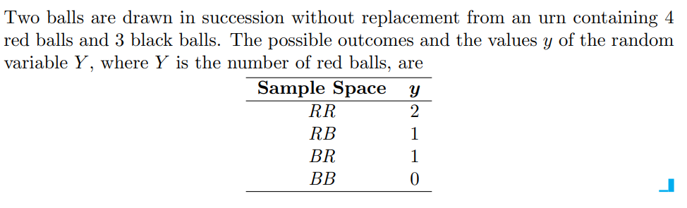

**Example:**

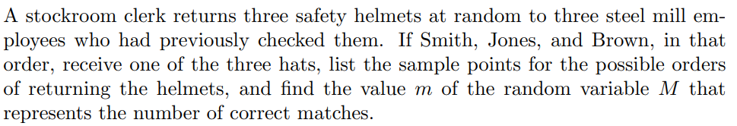

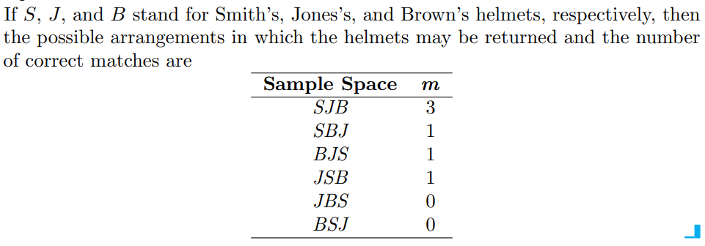

**Example:**

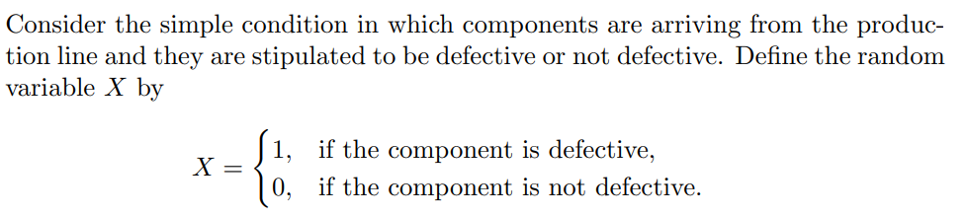

**The random variable for which 0 and 1 are chosen to describe the two possible**

**values is called a Bernoulli random variable.**

**Example:**

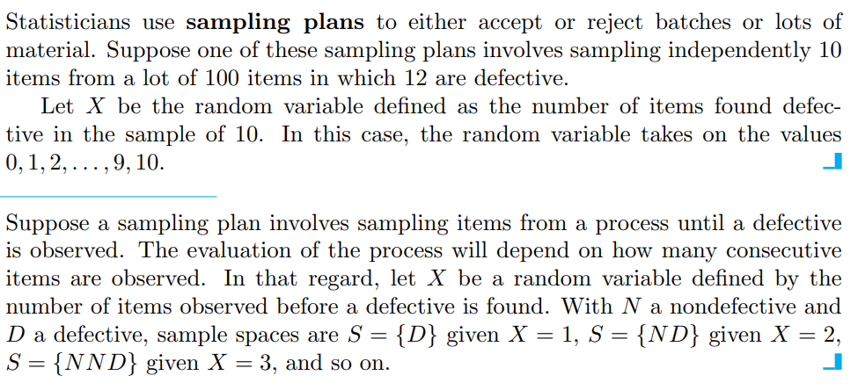

**Example:**

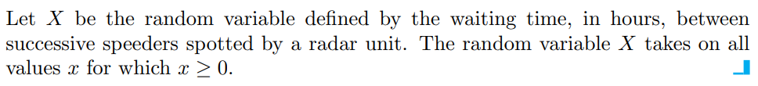

A random variable is called a **discrete random variable** if its set of possible outcomes is countable.

When a random variable can take on values on a continuous scale, it is called a **continuous random variable**.

**Probability Distribution Function**

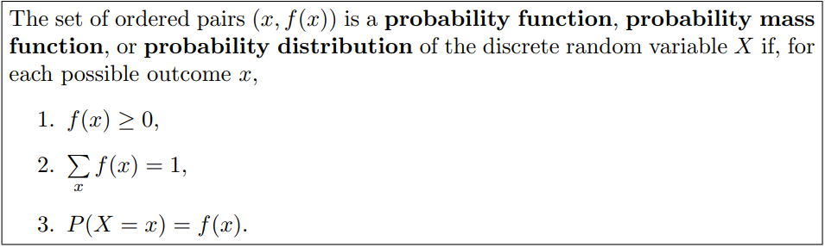

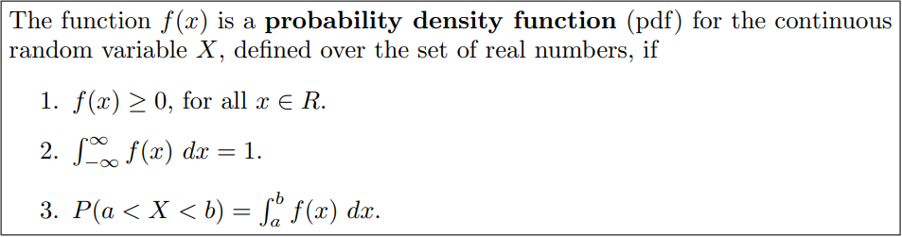

**Example:**

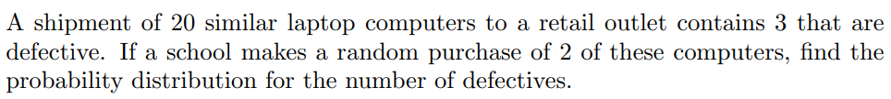



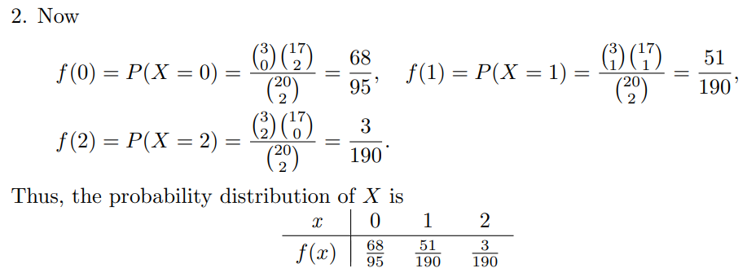

**Example:**

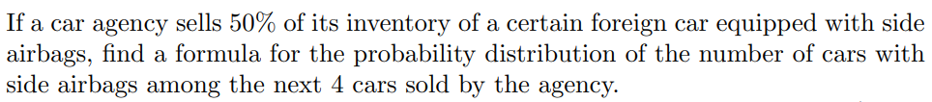

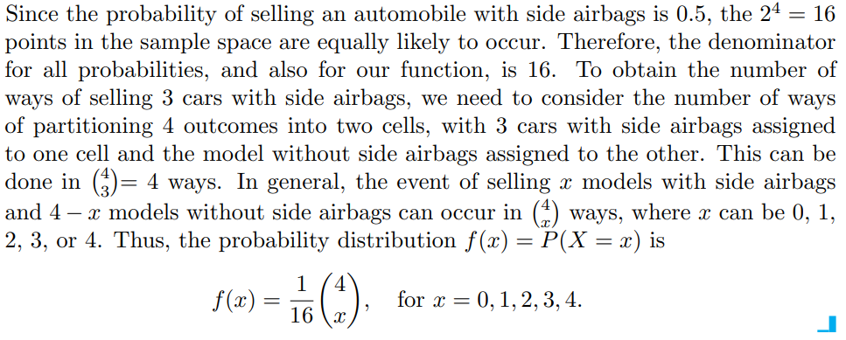

**Example:**

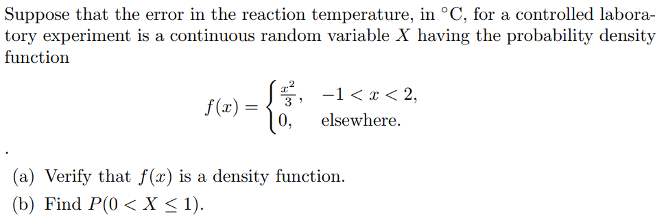

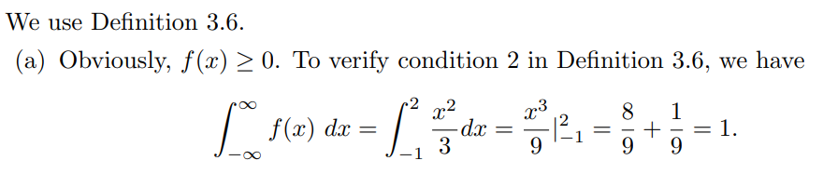

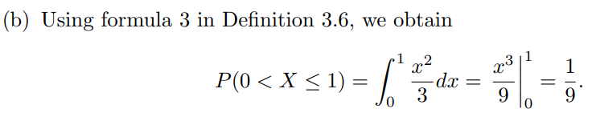

**Note:** When X is a continuous random variable then

That is, it does not matter whether we include an endpoint of the interval or not. This is not true, though, when X is discrete.

In fact, if ‘X’ is a continuous random variable then where is any constant.

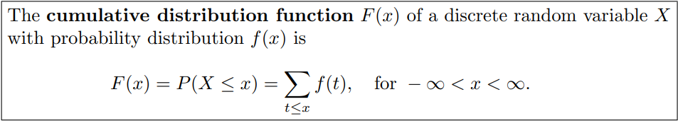

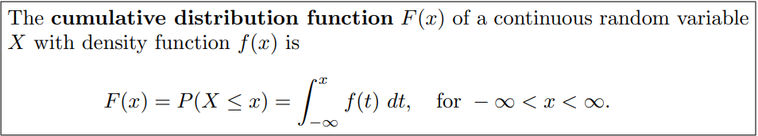

**As an immediate consequence of the above Definition, one can write the two results**

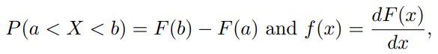

**if the derivative exists.**

**Example:**



Also find the cumulative distribution function of the random variable X.

Using F(x), verify that f(2) = 3/8.



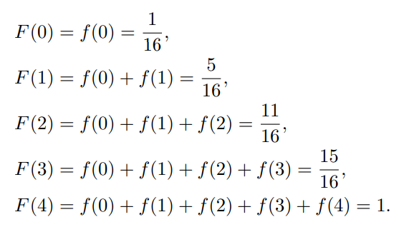 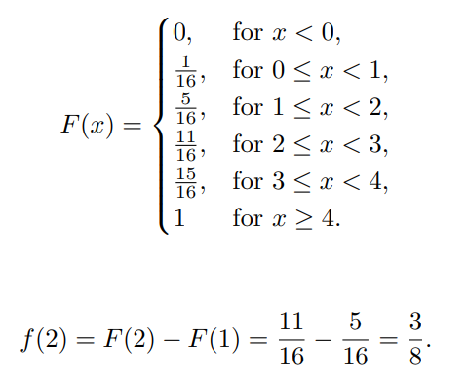

**Example:**



Also find the cumulative distribution function of the random variable M.



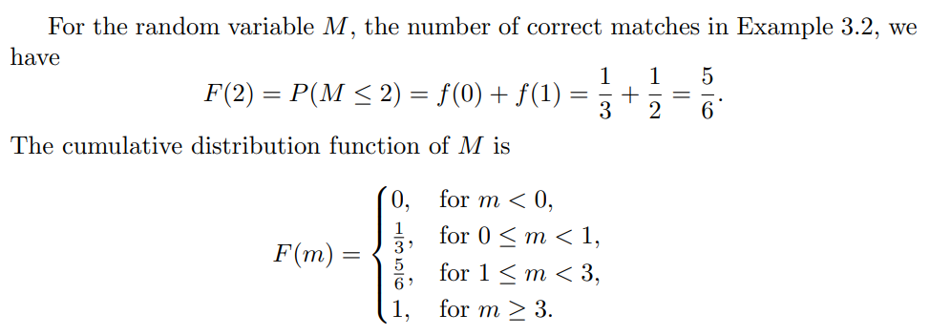

**Example:**



1. Find F(x), and use it to evaluate P(0 < X ≤ 1).

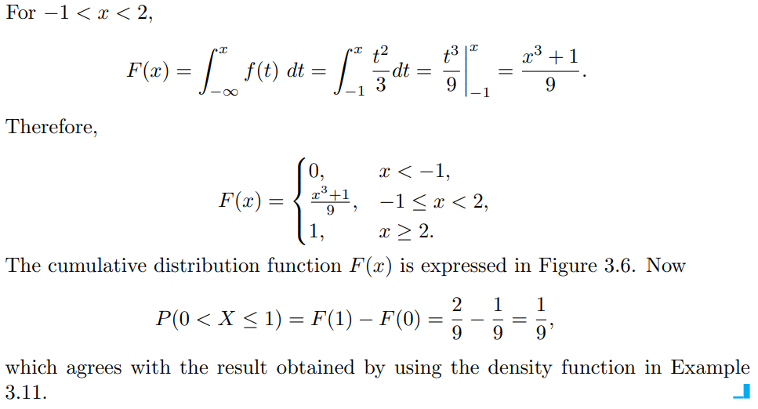

**Example:**

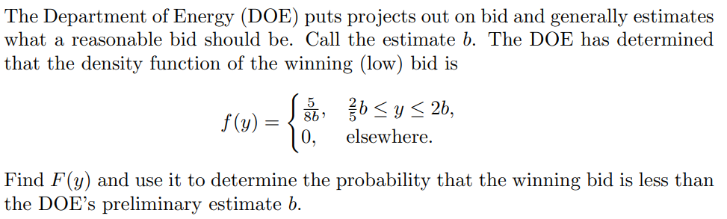

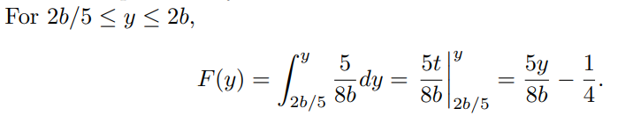

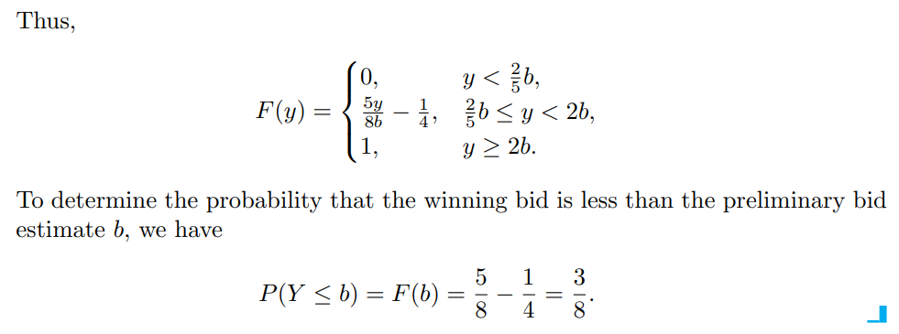

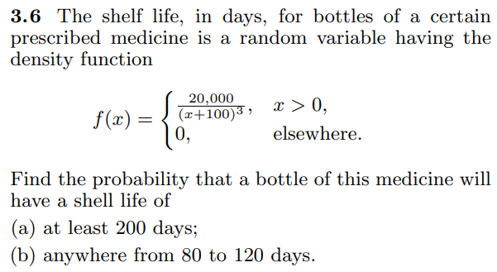 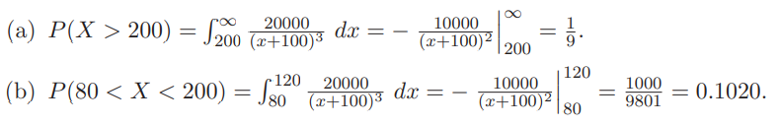

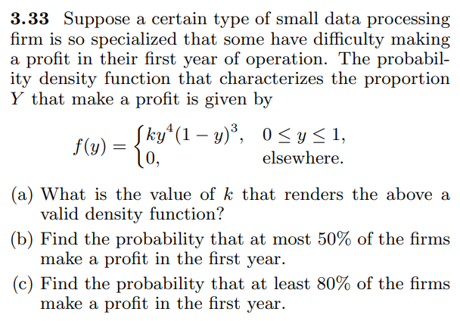

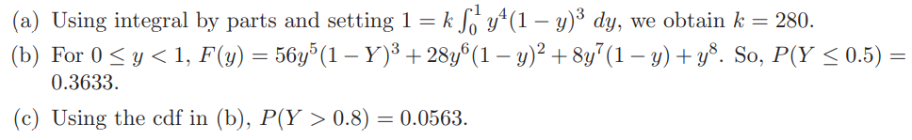

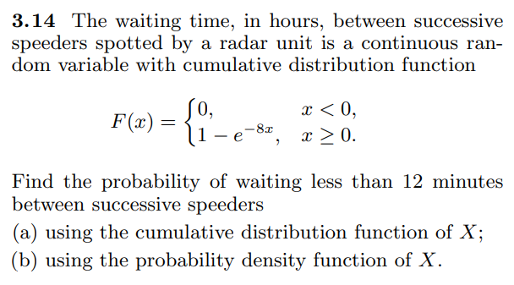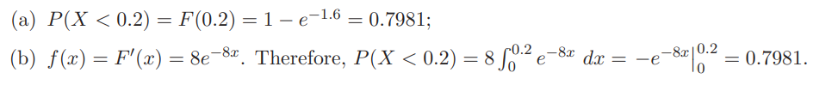

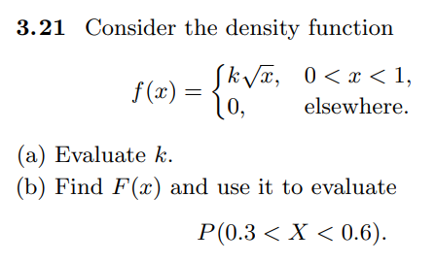

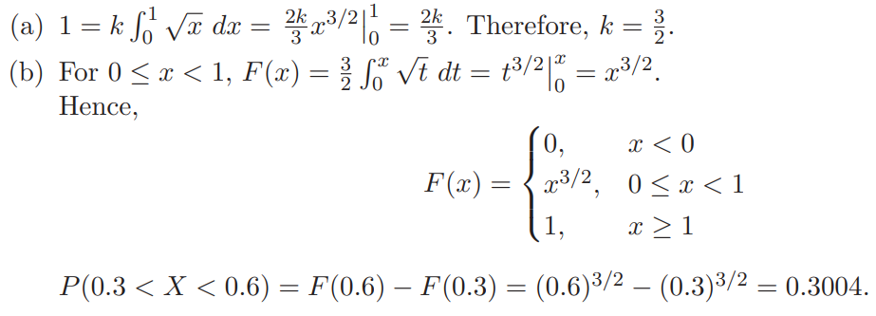

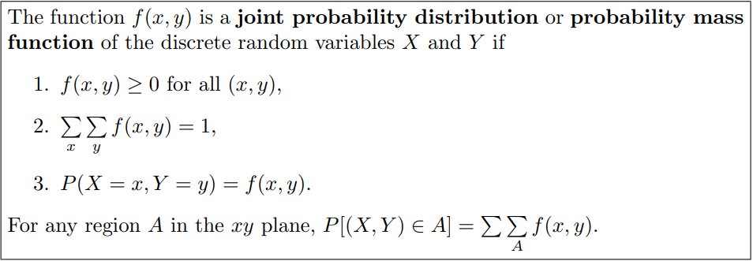

**Example:**

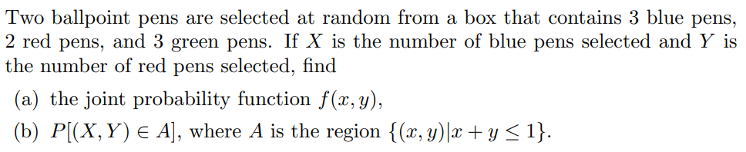

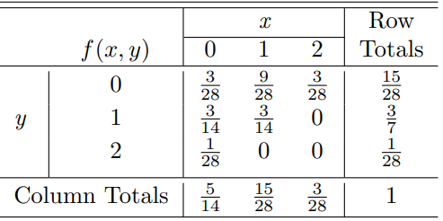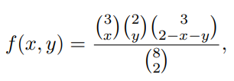

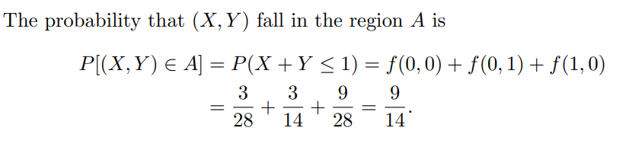

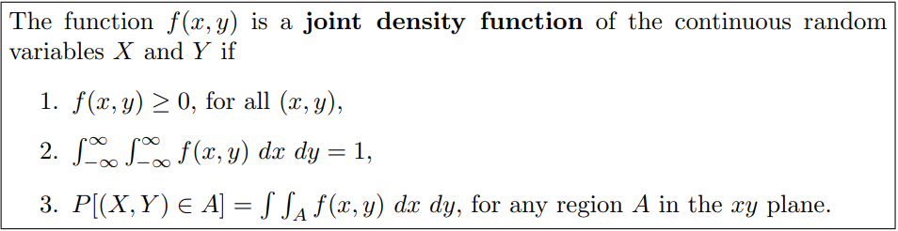

**Example:**

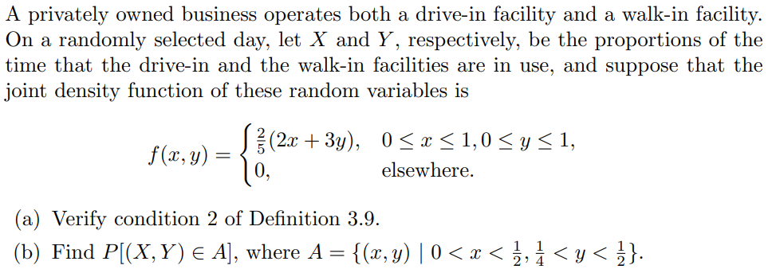

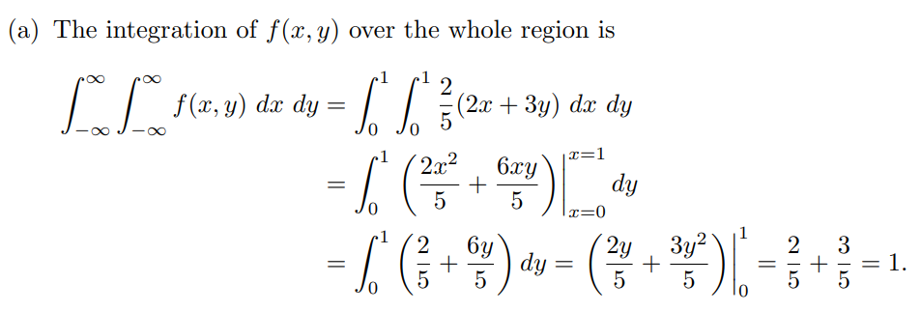

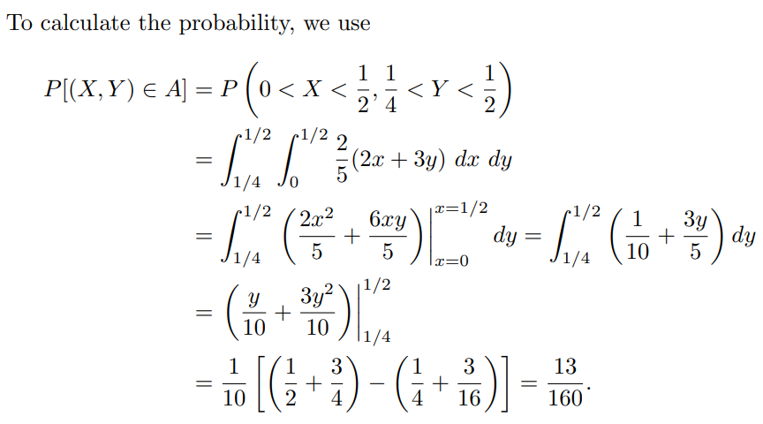

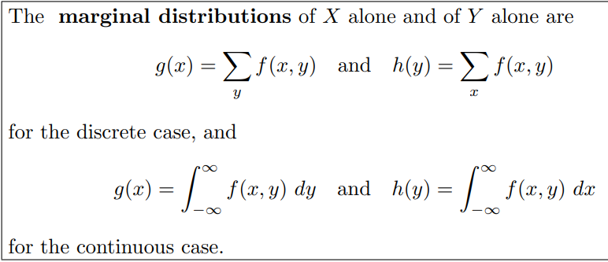

**Example:**





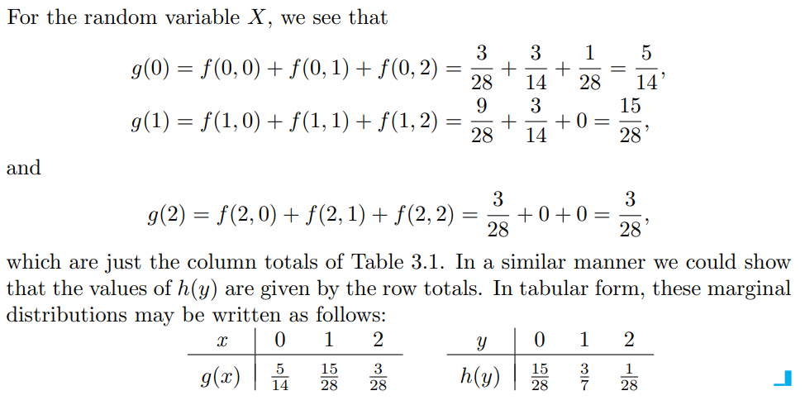

**Example:**



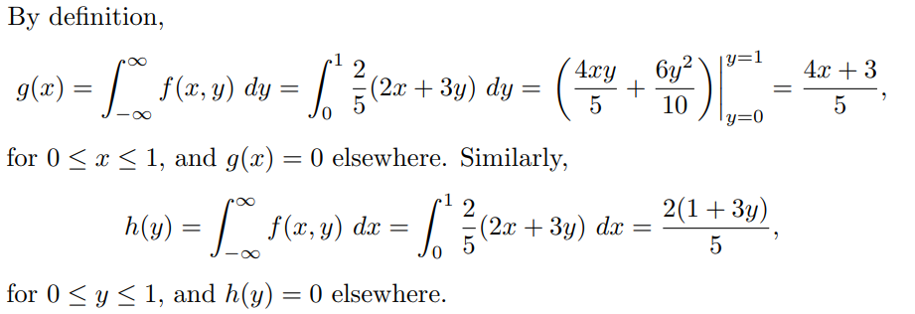

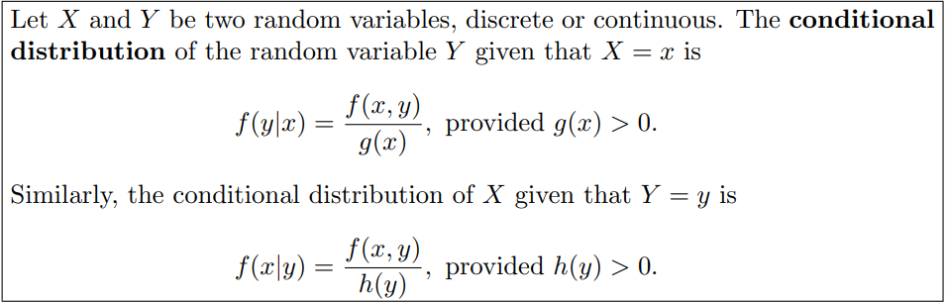

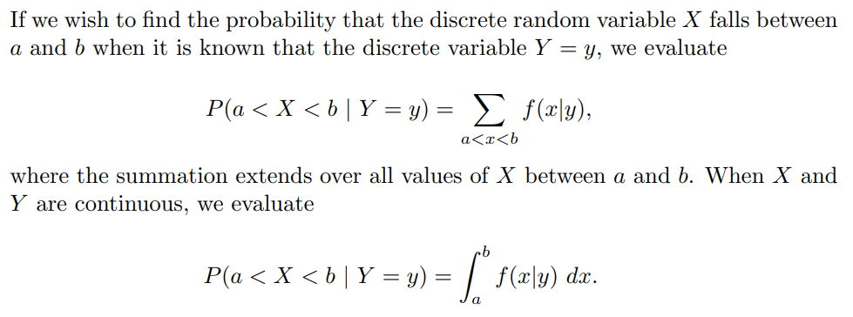

**Example:**



Find the conditional distribution of X, given that Y = 1, and use it to determine P(X = 0 | Y = 1).

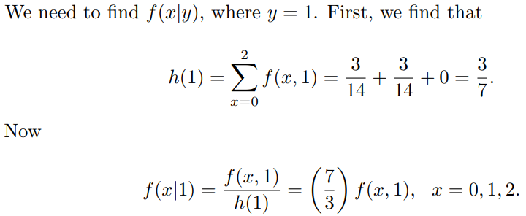



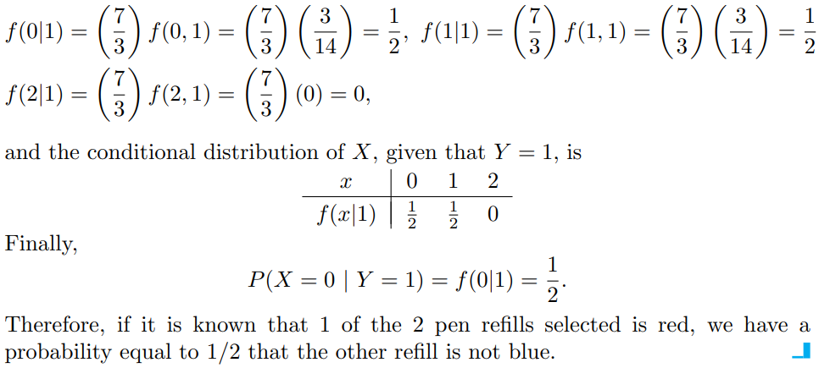

**Example:**

